**3.ASSIGNMENT NUMBER 3**

#include<stdio.h>

#include<string.h>

struct BarcelonaPlayer

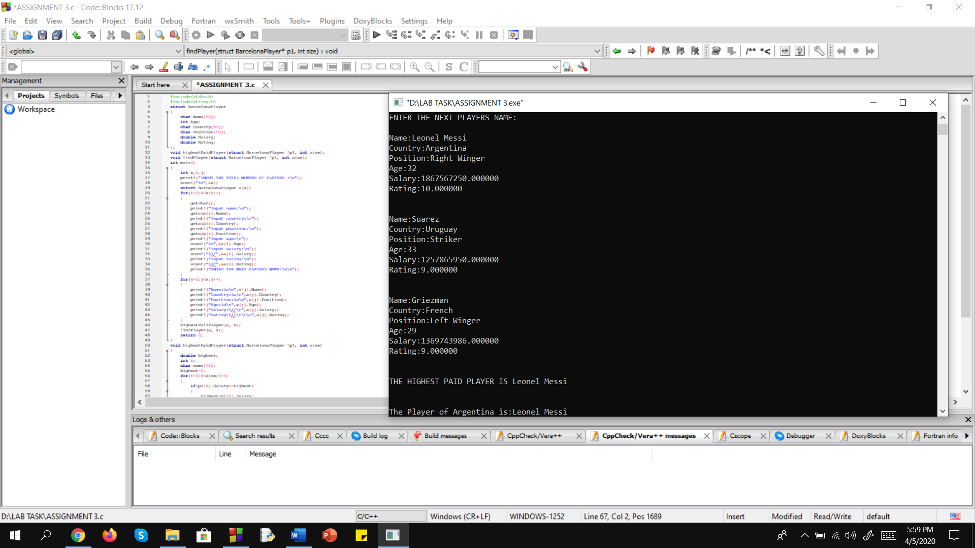{

char Name[50];

int Age;

char Country[50];

char Position[50];

double Salary;

double Rating;

};

void highestPaidPlayer(struct BarcelonaPlayer *p1, int size);

void findPlayer(struct BarcelonaPlayer *p1, int size);

int main()

{

int x,i,j;

printf("INPUT THE TOTAL NUMBER OF PLAYERS :\n");

scanf("%d",&x);

struct BarcelonaPlayer a[x];

for(i=0;i<x;i++)

{

getchar();

printf("Input name:\n");

gets(a[i].Name);

printf("Input country:\n");

gets(a[i].Country);

printf("Input position:\n");

gets(a[i].Position);

printf("Input age:\n");

scanf("%d",&a[i].Age);

printf("Input salary:\n");

scanf("%lf",&a[i].Salary);

printf("Input rating:\n");

scanf("%lf",&a[i].Rating);

printf("ENTER THE NEXT PLAYERS NAME:\n\n");

}

for(j=0;j<x;j++)

{

printf("Name:%s\n",a[j].Name);

printf("Country:%s\n",a[j].Country);

printf("Position:%s\n",a[j].Position);

printf("Age:%d\n",a[j].Age);

printf("Salary:%lf\n",a[j].Salary);

printf("Rating:%lf\n\n\n",a[j].Rating);

}

highestPaidPlayer(a, x);

findPlayer(a, x);

return 0;

}

void highestPaidPlayer(struct BarcelonaPlayer *p1, int size)

{

double highest;

int i;

char name[20];

highest=0;

for(i=0;i<size;i++)

{

if(p1[i].Salary>=highest)

{

highest=p1[i].Salary;

strcpy(name,p1[i].Name);

}

}

printf("THE HIGHEST PAID PLAYER IS %s\n\n\n",name);

}

void findPlayer(struct BarcelonaPlayer *p1, int size)

{

int i;

for(i=0;i<size;i++)

{

if(strcmp(p1[i].Country,"Argentina")==0)

{

printf("The Player of Argentina is:");

printf("%s", p1[i].Name);

}

}

}